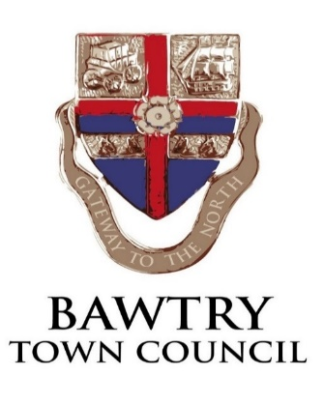
NOTICE OF ANNUAL TOWN COUNCIL MEETING
at BawtryTown Hall Station Road, Bawtry on MONDAY 11th May 2026 AT 6.30PM

Angela Harrison, Town Clerk 5th May 2026
AGENDA

- APPOINT A TOWN MAYOR FOR THE ENSUING YEAR
- DECLARATION OF ACCEPTANCE OF OFFICE BY THE CHAIRMAN
- RECEIVE APOLOGIES & APPROVE REASONS FOR ABSENCE.
- TO ELECT THE DEPUTY TOWN MAYOR
- TO RECEIVE MEMBERS’ DECLARATIONS OF INTEREST (other than standing interests)
- AGREE CONFIDENTIAL ITEMS Public Bodies (Admission to Meetings) Act 1960
- APPROVE MINUTES OF THE TOWN COUNCIL MEETING –13th April 2026
- MATTERS ARISING FROM THE MINUTES
- 15 MINUTE PUBLIC DISCUSSION PERIOD
- FINANCIAL MATTERS
- Approve monthly accounts to May 2026
- Receive bank reconciliations – to 31st March 2026 (Year End)
- Receive budget monitoring to 31st March 2026
- Approve updated Asset Register of land and other assets 2026
- Receive Internal Audit Report (AGAR pg3) and significant variances
- Note Commencement of the Exercise of Public Rights (3rd June-14th July)
- APPROVE AGAR SECTION 1 (GOVERNANCE STATEMENTS)
- APPROVE AGAR SECTION 2 (ACCOUNTING STATEMENTS)
- CONSIDER COUNCIL REPRESENTATIVES TO OUTSIDE BODIES
- (PCJCC) Parish Councils Joint Consultative Committee
- Town/Parish Council Climate Action Network
- YLCA South Yorkshire Branch (2)
- CDC Rights of Way Forum
- CDC CCTV Working Group
- BRA
- South Yorkshire Police Liaison
- OTHER GROUPS inc
- Town Council newsletter
- Council Audit
- Staffing Committee
- Town Strategy Working Group
- Health & Wellbeing
- Town Board
- WARD MEMBER/CDC OFFICER REPORT
- CONSIDER REQUIREMENTS FOR FUTURE SPONSORSHIP OF EVENTS BY THE COUNCIL
- MARKET HILL ISSUES
a) Consider additional railings along the car park/highway boundary.

- RECREATION ISSUES
- Clerk update and consider promotion of the Memorial Sports Ground
- TOWN HALL- Note possible grant funding from BAWP towards fencing.
- PLANNING ISSUES
- Applications
26/00640/FUL Martin Grange Cottage, Martin Grange Farm Lane. Erection of rear and side extensions following demolition of existing rear and side extensions and erection of garage on the existing footing.
26/00663/ADV Library, Doncaster Road. Display of 3no wall-mounted heritage display panels on the north-facing wall for information for the public and 2no lectern-mounted, panel on 2no legs, heritage display panels installed on the lawn to the east of the library.
26/00133/FUL 27 Westwood Road. Erection of a garage next to the existing car port, with an office in the roof space and 2 front dormers and an external staircase, following the demolition of the existing garage.
26/00711/FUL 3 Park Road Bawtry. Erection of a single storey porch side extension and a single storey rear extension.
- Planning Determinations
26/00238/FUL 3 Yew Tree Drive. Erection of a single storey side extension and extension to existing dropped kerb and driveway (Amended Plans) - Granted
25/02440/FUL 22 Church Street. Replacement of the existing windows to all elevations, the installation of a bi-fold door to the southern elevation and a door to the rear elevation, and the construction of a portico to the front entrance (Amended Plans) - Granted
- ITEMS FOR FUTURE AGENDA & DATE OF NEXT MEETING

